**PROJECT TITLE- REVENUE DATA ANALYSIS**

Student Name: Durgesh Nandini ERP ID: 6604982

Branch:IT

Course Name: Data Analytics

# • 1. Introduction

* In this project, I conducted a data analytics study to explore the revenue and sales trends of a business based on a dataset named Dataclean.csv. The dataset contains transaction-level data including invoice details, customer names, cities, sales volume in quintals, and revenue. The goal of the project was to identify patterns, top-performing customers and cities, and generate visual insights that could be used for better business decision-making.
* **2. Dataset Overview**
* **Total Records:** 88 • **Columns in Dataset:**
  + **DATE**: The date of each transaction
  + **BILL NO.**: The invoice number
  + **RECIEVER**: Name of the buyer or customer
  + **CITY**: City where the transaction occurred
  + **QUINTAL**: Quantity sold (in quintals)
  + **AMOUNT**: Revenue earned from that transaction
  + **MONTH & YEAR**: Time features extracted from the date
  + **REVENUE_PER_QUINTAL**: Calculated revenue per quintal (constant value)
* The dataset was clean and mostly structured.

**3.Data Analysis and Visualizations**

* **Monthly Sales Trend:**
* I grouped the data by Month and calculated the total revenue:
* **Highest revenue months**: June and July
* **Lowest revenue months**: April and March
* This indicates the business has a strong mid-year performance.
* **Top 5 Customers:**
* Using both Python and SQL, I identified the top 5 receivers by revenue:
* Jai Jagdamba Trading Co.
* 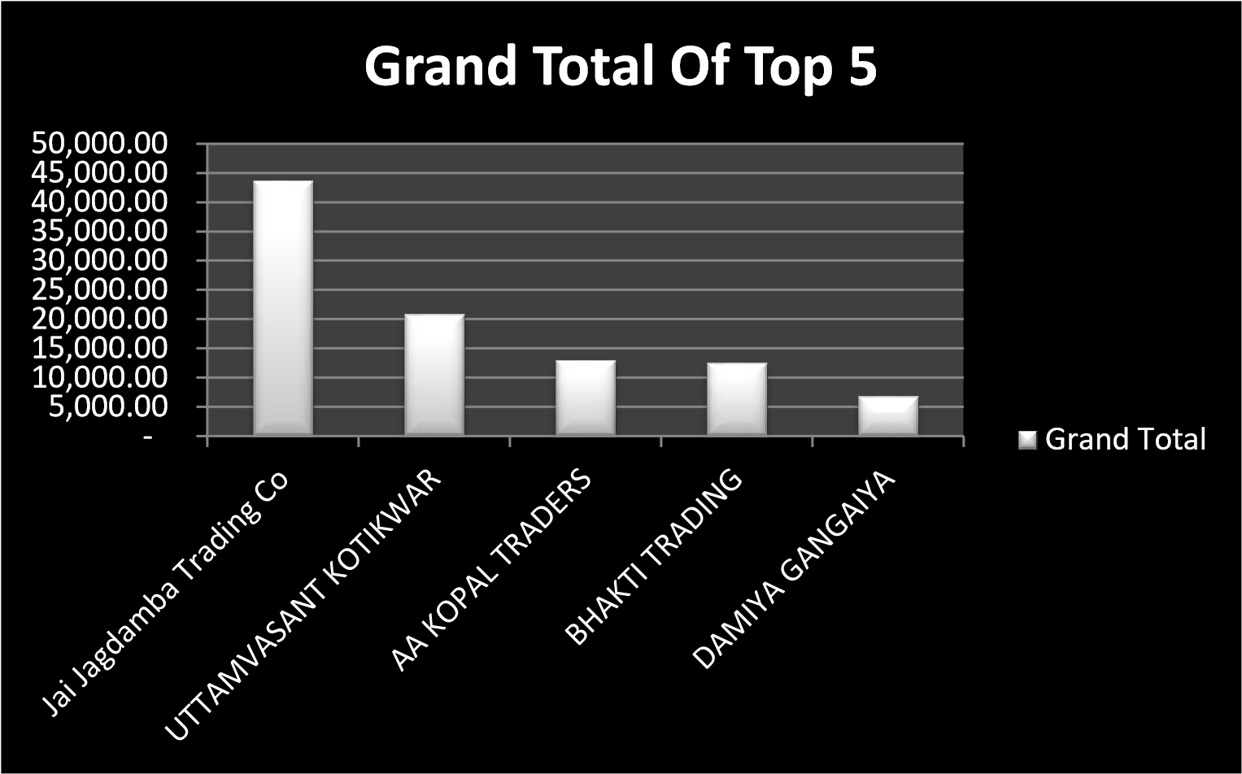Uttambasant kotikwar
* AA kopal
* Bhakti trading
* Damaiya Gangaiya

**4. Tools and Technologies Used**

|  |  |
| --- | --- |
| Tool  Python (Pandas, Matplotlib, Seaborn)  SQLite  Excel  Jupyter Notebook | Purpose  Data cleaning, analysis, and visualization  Writing and executing SQL queries  Dashboard creation using pivot charts  Combined code execution and documentation |

Cities With Maximum Revenue

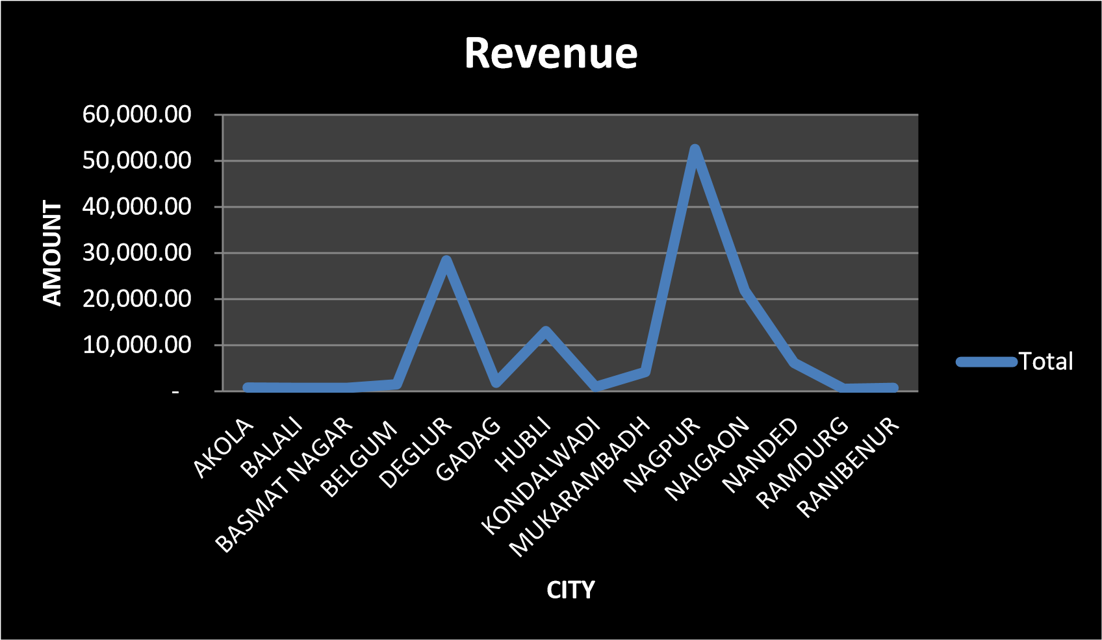

# Conclusion

This project helped me apply my data analytics skills using Python, SQL, and Excel. I was able to derive valuable business insights from a relatively small dataset by using the right tools and techniques. The visualizations provided clear patterns in terms of sales trends, customer behavior, and city performance.